Student Name: Laszlo Szlatki

Student ID number: 18169902

Student Group Number: group07

Group being tested: group01

Date of test: 02/April/2020

1. Was there an index.html file? Was it obvious what the website was from the first page?

Index.php was present in the group01 library, had no issues accessing the site. I wasn’t sure it was a dating site from the login.php page (index.php redirected to login.php). Could have been for tag a war ☺

1. What is the site for? Describe the sort of people that the site targets.

Making/collecting friends?? Not sure if the site has a clear target audience. No describing story or explanation of what is the site about on the main page; looks like anyone passing by can register if they wish. There aren’t any details visible from the users other than their name. Lack of user details makes it even harder to decide who this site is for.

1. How well did the individual registration section work? What happened when you put in malformed input (for example, mismatched passwords, wrong types, etc.)?

* At registration, the register button is not clickable, while details are incomplete/incorrect
* Site didn’t let me register with the same email address twice
* Warning for the need of last name
* Warning for the need of email address
* Password confirm red and register button inactive, unless password matched
* Email field enforces correct pattern ([xxxx@xxx.xx](mailto:xxxx@xxx.xx))
* Warning if password is too short (required min 11 character), but no notification of required length, when entering email. Only after confirming the same.
* Didn’t let me register with first name only (Shrek), last name only is OK though
* Login process successfully checks and alerts if incorrect email (user not registered) or incorrect password entered.

Few issues regarding registration:

* When I tried to register with the same Firstname, Lastname and email address, I’m not sure what happened. Didn’t see the “New record created successfully” message, but didn’t get a warning that user or email is already registered. I was expecting a notification that registration unsuccessful, or email already registered.
* Found a combination of steps, that if repeated, site won’t let user register with only last name entered. Steps to reproduce are detailed in the appendices.
* Managed, to register a user with mismatching password and confirm password fields. Steps to reproduce are detailed in the appendices.
* Header is redundant at the login and registration pages.
* After successfully registering to the site, I had difficulties finding the way to log in. By clicking home, it brought me to the login page. (Suggestion: after successful registration, redirect to login page)
* While trying to log in, the “forget your password” link doesn’t work
* When logging in and selecting “remember me” button, next time the fields are still not filled in ☹
* After logging in, I was brought to the index.php (recommendations) page, where the footer doesn’t stay at the bottom when scrolling (in Firefox)
* I was a recommended friend to myself ☺

1. Did the search function work?

* Search works on user name only. Unsuccessful search for gender, age, interest, location.
* Site doesn’t store additional information of the users, so nothing else to search for at the present
* Search only works if more than 2 characters were entered. Entering 1 or 2 character only, search will return all users.
* As per the search results, I could add myself to be my own friend
* Add button has no function at the moment
* Search box on allUsers.php page is more fitting to the page then the search box on the main page. Add button doesn’t work on either pages.

1. What was the “look and feel” of the site like? Was it pleasant to use or were there rendering problems and/or missing links?

* Site loaded quickly
* My Profile menu is confusing.
  + Log out placed inside my profile
  + Settings are not functioning or not applicable to current project.
* “Admin” menu item is redundant when an ordinary user is logged in
* “Registration” menu item is redundant in the header, since user has already registered and logged in.
* Logo not clickable
* On login page, forgot my password doesn’t work
* On login page, remember me tickbox doesn’t work
* On index page, add friend button has no function
* On index page, clicking on the user’s name has no function
* On index page, when scrolling, footer won’t stay at the bottom of page
* On index page, search box appearance not consistent with the rest of page
* On search results, add button has no function
* Also last item not visible from the footer, yet no scroll bar appears (if zoomed more in, scroll bar appears. If zoom out, last item is visible)

1. Do you have any additional suggestions or advice for your classmates? If so, please make them here.

* Keep well and stay safe.
* See below for more details, screenshots and steps to reproduce issues.

When I tried to register with the same Firstname, Lastname and email address, I’m not sure what happened. Didn’t see the “New record created successfully” message, but didn’t get a warning that user or email is already registered.

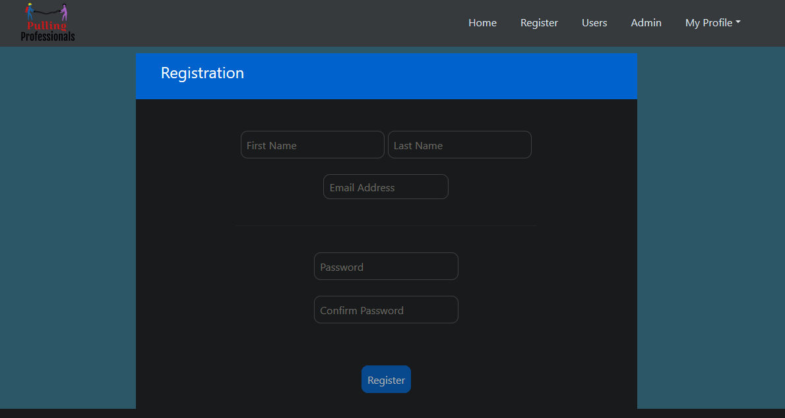

Also didn’t let me register 2 different users with the same e-mail address, but same name is OK

Register button not clickable while password and confirm password mismatch

Email field enforces correct pattern ([xxxx@xxx.xx](mailto:xxxx@xxx.xx))

Warning when password is too short (min 11 character, but accepts any combination though i.e.11111111)

Didn’t let me register with first name only (Shrek), last name only is OK though. Got to a stage, when I had all necessary fields completed, but still had the warning to “Please enter name” and register button not clickable

Steps to reproduce:

* fill in all details (f.n; l.n; email; psw; confirm psw)
* Delete last name (get the warning to fill in last name)
* Delete first name (warning changes to “Please enter name”)
* Fill in last name (enter name warning stays, yet possible to register as is)

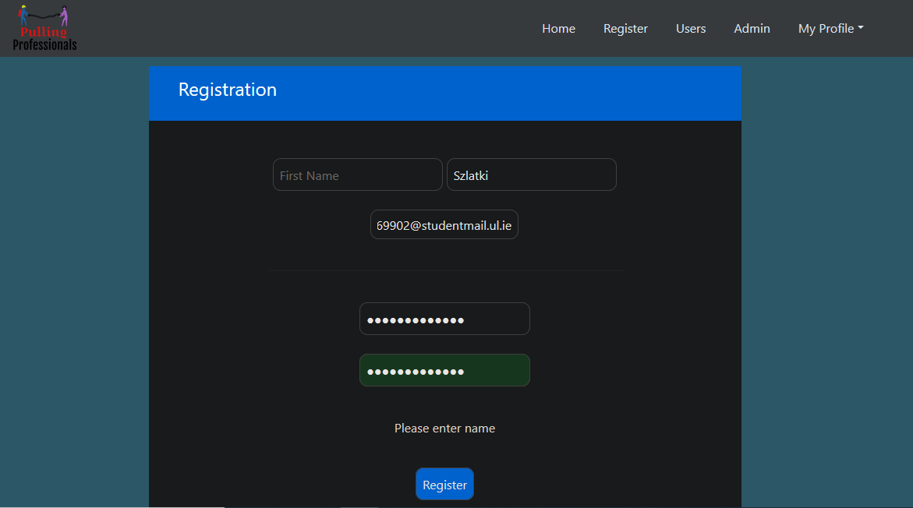

Managed, to register a user with mismatching password and confirm password fields

Steps to reproduce:

* Fill out all details (fn, ln, email, password, confirm)
* When password confirm field turns green, and Register button activates, delete some characters from the confirm password field
* Also works, if delete some characters from password

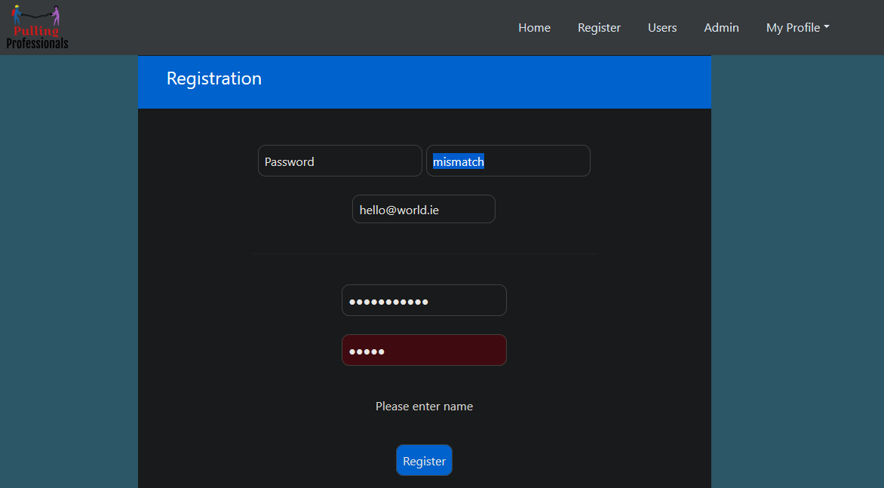



After successfully registering to the site, I had difficulties finding the way to log in. By clicking home, it brought me to the login page.

Header is redundant on the registration page. User shouldn’t be able to click on “My Profile” while hasn’t even registered yet.

Suggestion: after successful registration, redirect to login page

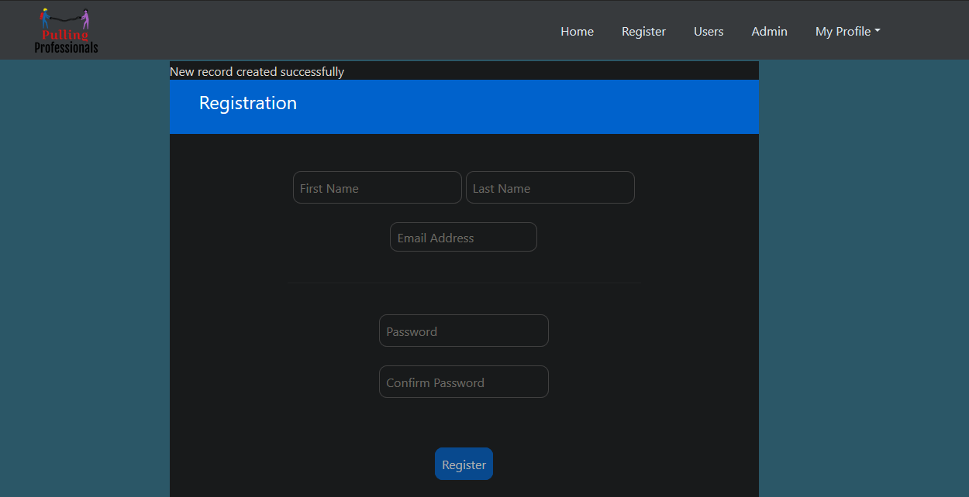

Logging in successfully checks and alerts if incorrect email (user not registered) or incorrect password entered.

While trying to log in, the “forget your password” link doesn’t work

When logging in and selecting remember me, button, next time the fields are still not filled in ☹

After logging in, I was brought to the index.php (recommendations) page.

* Footer doesn’t stay at the bottom when scrolling (in Firefox)

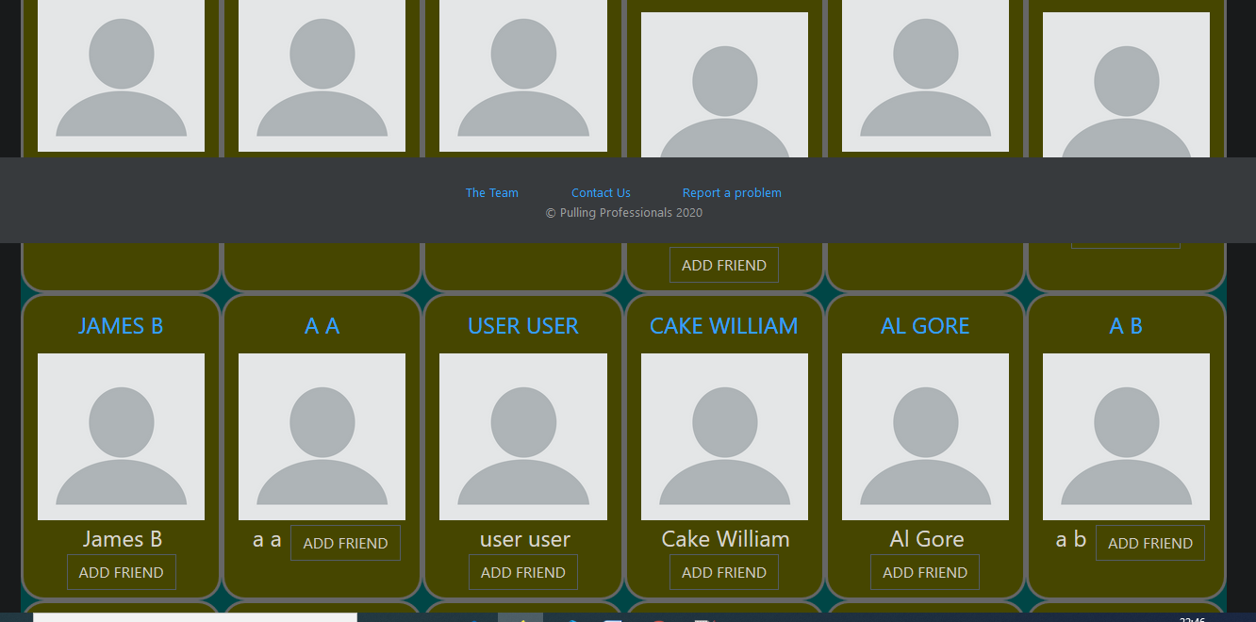

* I was a recommended friend to myself ☺

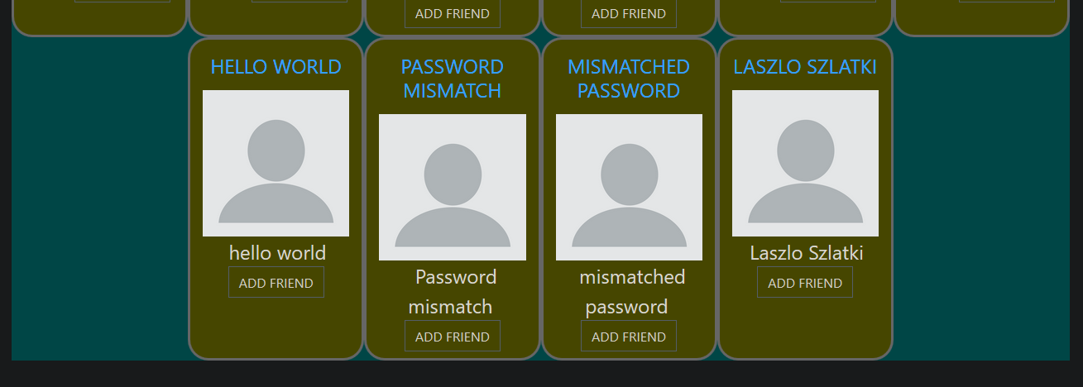

Search: not sure what is it searching for (guessing, part of the username???)

* Search box (on index.php) appearance not consistent to rest of pages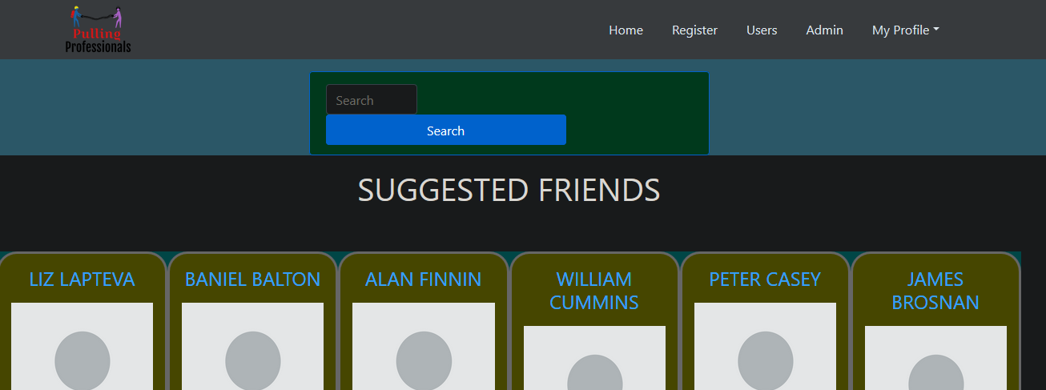
* If only 1 or 2 characters entered, all users are returned as found
* If 3 or more characters entered, suggestions are filtered per name
* Search box on allUsers.php page is more fitting to the page
* Add button doesn’t work

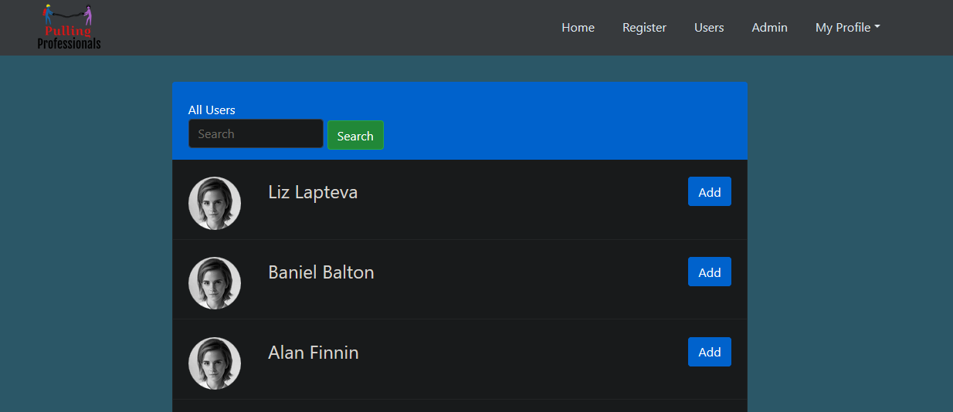

My profile settings: settings are not working, some are not applicable.

Also last item not visible from the footer, yet no scroll bar appears (if zoomed more in, scroll bar appears. If zoom out, last item is visible)

